

DIPLOMA PROGRAM RESEARCH PROJECT
SYSTEM SPECIFICATIONS DESIGN
PROJECT TITLE: NAZARETH RUIRU HOSPITAL MANAGEMENT SYSTEM
UNIT CODE: 503
NAME: PAUL KURIA
REG NO: 18/03068
EMAIL: paulkush7777@gmail.com
SUPERVISOR’S NAME: MR. FRED OMONDI

SYSTEM DESIGN SPECIFICATION

PURPOSE AND SCOPE
This document introduces the necessary design to be adopted and implemented for the development of Nazareth Ruiru Hospital management system.
This document provides a clear outline of the system and the actual implementation of the requirements. This is a hospital system that registers new patients, their medical details and the staff members in the hospital.

SYSTEM OVERVIEW
The system will follow the client - server architectural style whereby the client requests for services from the server while the server provides the requested services depending on the rights provided due to authorization and authentication.

Staff
Administration

All the users of the system will be served depending on their requirements:
Staff makes changes concerning the patients
Administrator will be in charge of adding and or removing new staff members to the system and update the system.

Level two Data Flow Diagram

Data flow level one reveals the general processes and data stores.

Booking


The figure above shows the flow of commands in the system
The administrator of the system will be responsible for adding new users to the system and update staff details.
The user(operational managers) will be responsible for login into the system, update information concerning patients and appointments.

ADMIN
Update Staff Details
Staff
Update patients information

SYSTEM ARCHITECTURE
The system and subsystem architecture are described below beginning with the users, then the hardware and the interfaces.

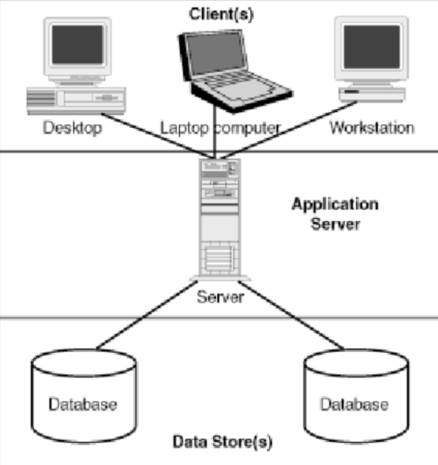

System Architecture

The above system interacts with other applications on the application layer. It interacts with users in the user interface the users it interacts with are as explained in.
The kind of data they input into the system is well explained below.
The system needs several hardware’s to be able to perform optimally and the hardware requirements below indicate what are required.
Data entered into the system is stored in the database in the format indicated in the data dictionary.

5.3 USERS
The users of the system will be:
Administration
-Registering new customers to the system.
Staff
- Registering new patients to the system.
- Booking appointments.
- Search for details concerning staff members.

5.4 HARDWARE REQUIREMENTS
The hardware required for the system will include:
- A computer- there can be more than one computer where one can act as the server while the others act as the clients that can be used by the users of the system
- A printer- the printer will be used to print receipts and any other report from the system
- Flash disks/ hard drives this will be used to store all the documentation for the system this will be for easy retrieval when need be.
- CD ROM- this will be the backup for the system.

5.6 SOFTWARE DESIGN
This system will have several users to perform several tasks depending on the responsibility assigned to the user.
- The administrator will create a new user account for the customer’s, carry out maintenance of the system.
- The operational managers update all made purchases.

Admin/Staff user pseudo code
- log in
- If credentials are wrong then clear the text fields and indicate wrong credentials
- Else If credentials are correct indicate correct registration and manipulate database.
- End if
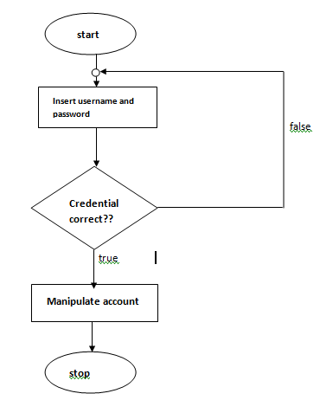

5.7.2 PHYSICAL DESIGN

DATA DICTIONARY

ADMIN TABLE
COLUMN | TYPE | NULL | DEFAULT
user_id | Int (11) | No
Username | Char (20) | No
Password | Char (20) | No

PATIENTS’ DETAILS

COLUMN | TYPE | NULL | DEFAULT
Patient No | Int (10) | No
First Name | Char(10) | No
Last Name | Char (10) | No
Email address | Char (20) | No
Contacts | Int (20) | No
Emergency Contacts | Int (20) | No
Home Address | Int (20) | No
Date of Birth | Date/time | No

STAFF’S DETAILS

COLUMN | TYPE | NULL | DEFAULT
Staff No | Int (10) | No
First Name | Char(10) | No
Last Name | Char (10) | No
Email address | Char (20) | No
Contacts | Int (20) | No
Emergency Contacts | Int (20) | No
Home Address | Int (20) | No
Date of Birth | Date/time | No

APPOINTMENT’S DETAILS

COLUMN | TYPE | NULL | DEFAULT
First Name | Char(10) | No
Last Name | Char (10) | No
Doctor’s Name
Email address | Char (20) | No
Phone Number | Int (20) | No
Date of Birth | Int (20) | No

HUMAN-MACHINE INTERFACE

TABLE LOGIN
COLUMN | TYPE | NULL | DEFAULT
Client ID | Char (20) | No
Password | Char (20) | No
Date registered | char(10) | No

STAFF/PATIENT TABLE
COLUMN | TYPE | NULL | DEFAULT
Staff/Patient No | Int (10) | No
First Name | Char(20 | No
Last Name | Char (20) | No
Email address | Int (20) | No
Contacts | Int (20) | No
Emergency Contacts | Int (20) | No
Home Address | Int (20) | No
Date of Birth | Date/time | No

APPOINTMENT TABLE

COLUMN | TYPE | NULL | DEFAULT
First Name | Char(10) | No
Last Name | Char (10) | No
Doctor’s Name
Email address | Char (20) | No
Phone Number | Int (20) | No
Date of Birth | Int (20) | No

HUMAN-MACHINE INTERFACE
This section provides the detailed design of the system and subsystem inputs and outputs relative to the user.
- System Input Interface Design

Administrator form

Allows the administrator to login, update the staff details, check performance level, perform maintenance, and change passwords.

Staff login form
It only allows restricted users to the system.

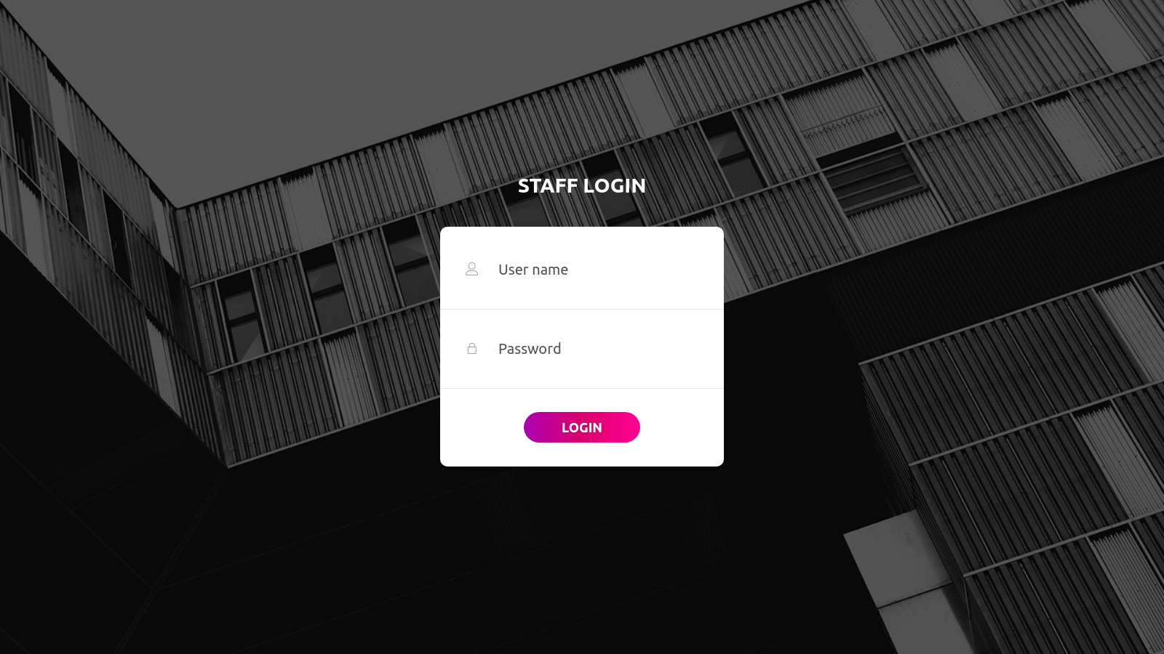

Home Page
Gives brief information about the hospital to the user.

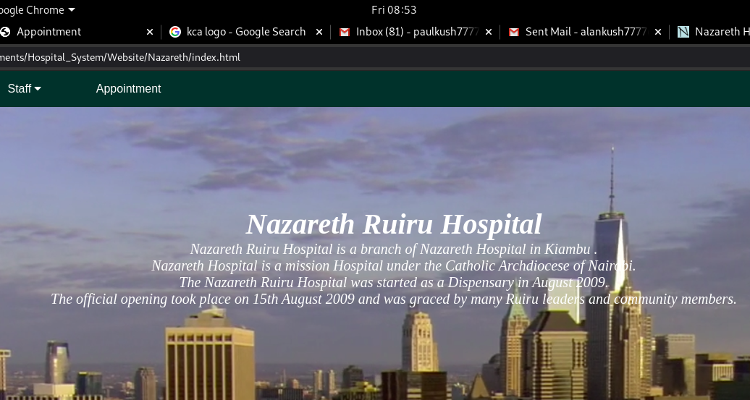

Navigation Bar
Links enable movement through pages
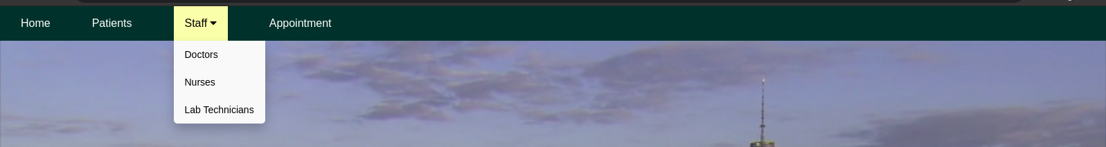

Patients Page
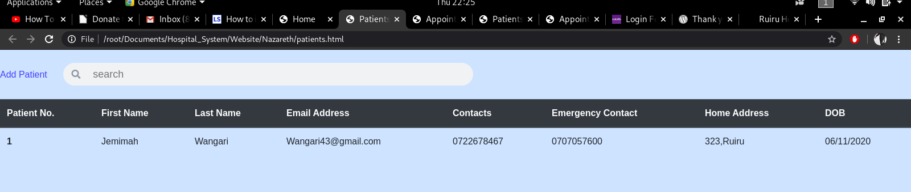
Displays the patients in the database.

There is a link Add Patient which takes you to the fill form for new patients.

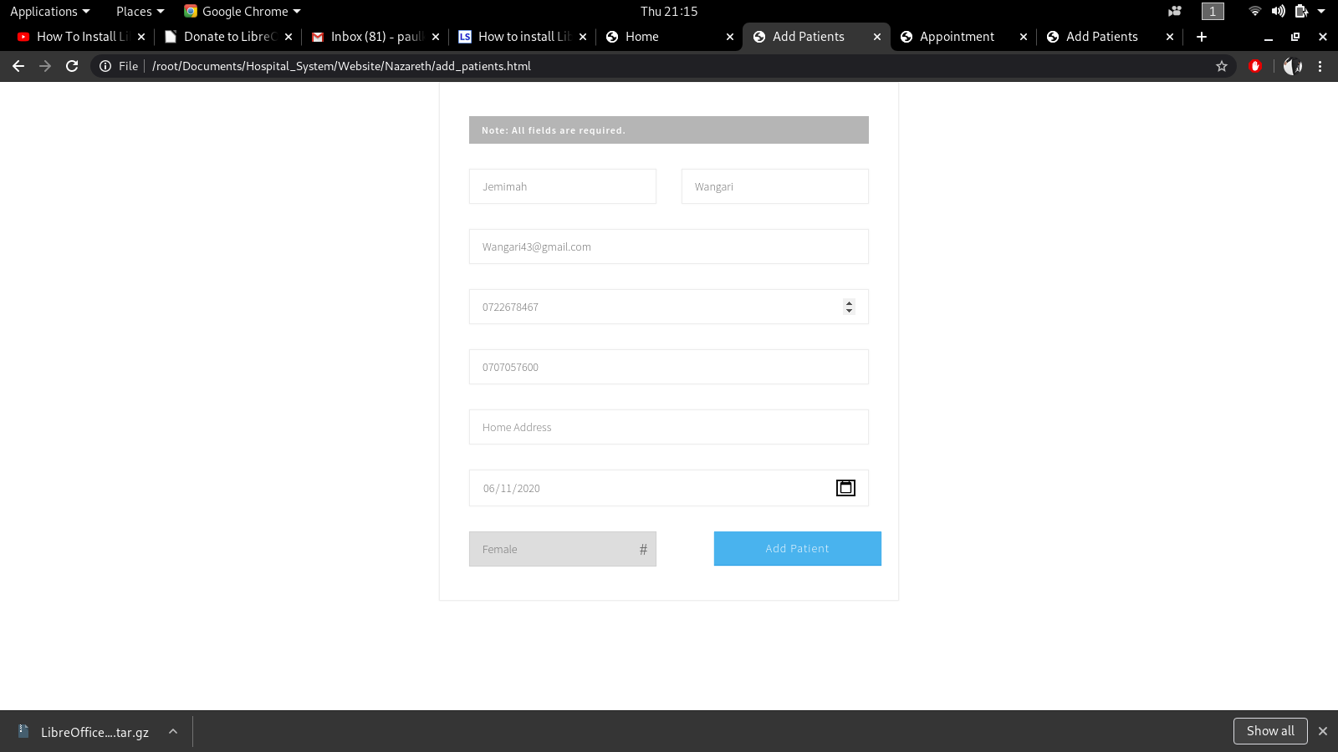

Patients medical information is displayed when clicking on the patients name.

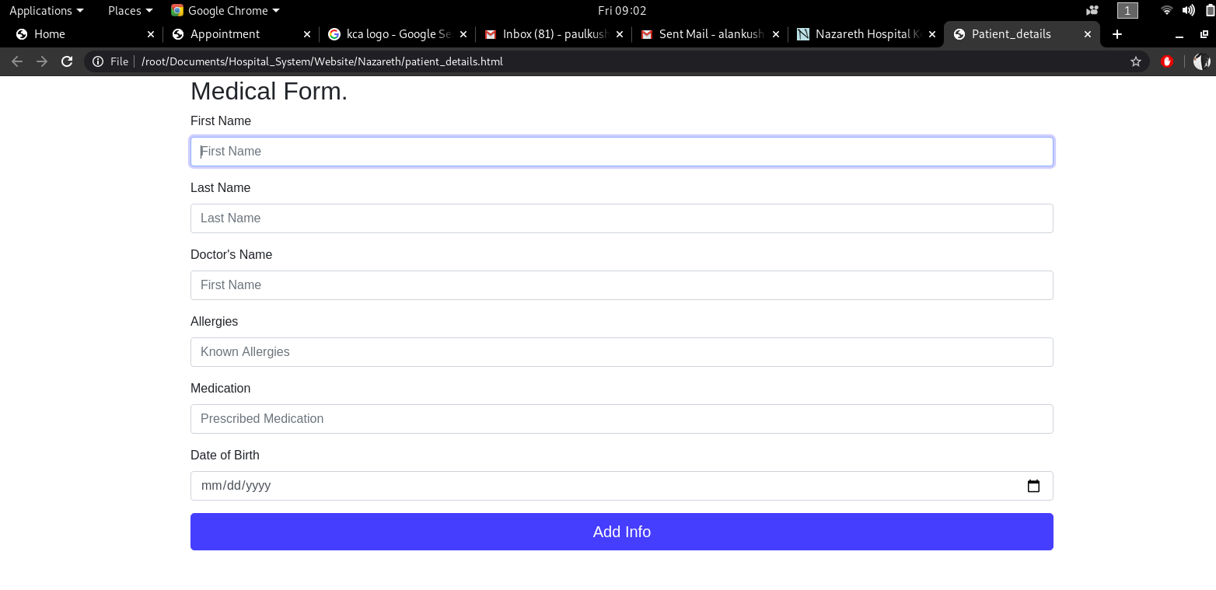

STAFF
All the pages here only display the list of staff members added by the administrator.
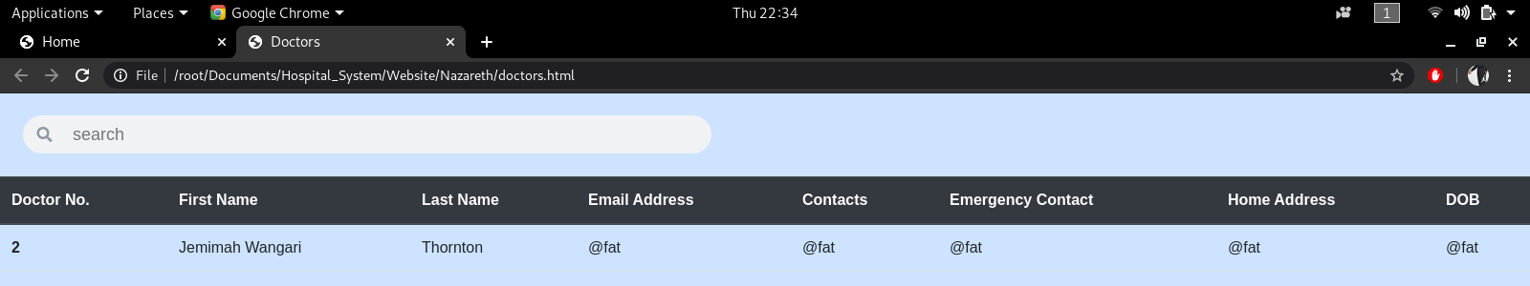

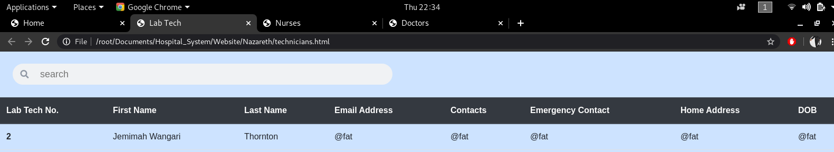

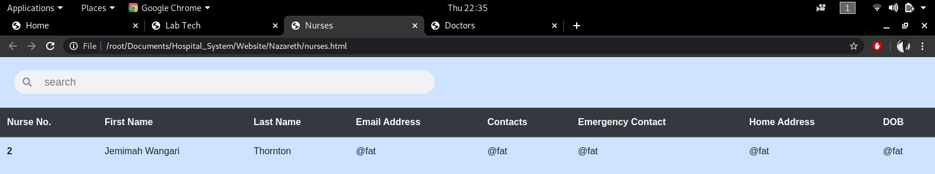

Appointment Page
Displays the already placed appointments.
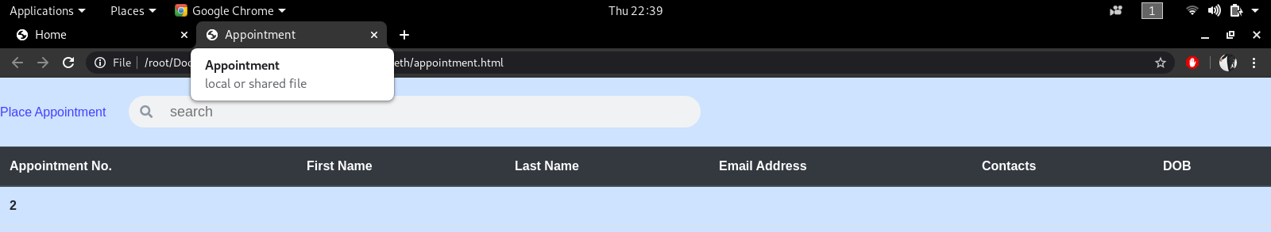

There is a link Place Appointment which takes you to the fill form for new appointments.

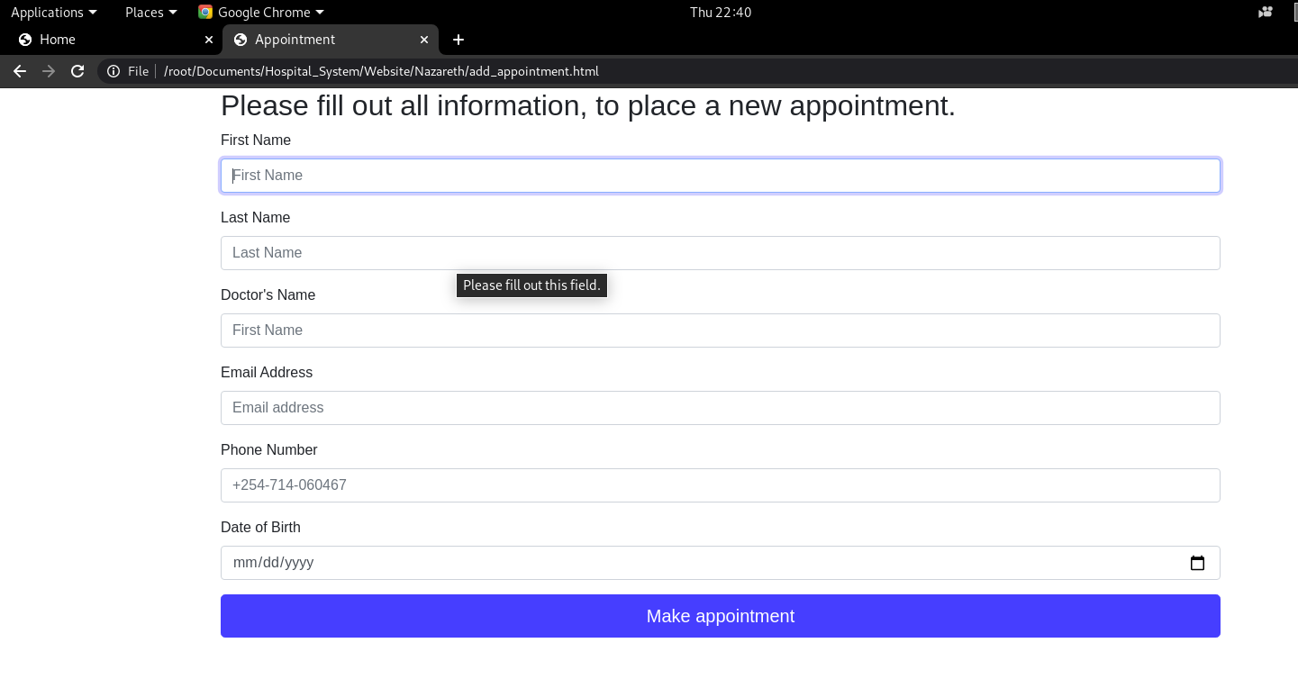

SYSTEM INTEGRITY CONTROLS
The system should authenticate both the administrator and user before they proceed to their respective forms as each of these users have different functions to play in the Hospital management system.
The system should ensure that when a user logs in each of the activities done are recorded such a time of login and name of the user ensure that when misuse or modification in the system is done the culprit can be identified.
The system should ensure that only the required information can be edited, modified or deleted to ensure that the critical data in the system cannot be tempered with which may cause damage to the system.

SYSTEM EVALUATION, RECOMMENDATION AND REFERENCES

SYSTEM EVALUATION

This project is designed to meet the requirements of Nazareth Ruiru Hospital.

DESIGN
The system is designed in a simple way that shows information where you only need to know how to read the user manual in order for you to use the system.

SUMMARY OF RESULTS
- I observed that the system is able to add new users through the administrator.
- I observed that the system is able to add new patients and book appointments.
- I observed that the system is able to validate username and passwords

7.3 CONCLUSION
- The system is safe from unauthorized personnel gaining access because each person has to have a password and username.
- The system was able to add users and delete users.
- The system was able to add data to the database.

PROJECT STATUS
Completed tasks
- Created electronic file system.
- System can add user and also delete the user.
- A user can log into the system successfully.
- The system can add relevant information to the database.
LIMITATIONS OF THE STUDY
- It may require updates in future hence may require larger space in memory.

